Installation Qualification (IQ)
- IQ-TC-01: Binary Integrity & Versioning Verification (Ref: UR-DI-08)
Objective:
To verify that the delivered AirQualityReview.exe is correctly installed, matches the validated build baseline, and contains the officially approved version metadata.
Procedure:
  - System Installation:
- Locate the source installation package (standalone executable).
- Copy the AirQualityReview.exe file and its associated data folders to the target local drive
  - Navigation and Metadata Verification:
- Open Windows File Explorer.
- Navigate to the directory where the application was copied (e.g., C:\AQR_System\).
- Right-click on the file AirQualityReview.exe.
- Select 'Properties' from the context menu and navigate to the 'Details' tab.
  - Command-Line Integrity Check (SHA-256):
- Press the Windows + R keys on the keyboard to open the 'Run' dialog box.
- Type powershell in the Open field and press Enter or click 'OK'.
- In the PowerShell window, type the following command to change the directory to the application folder: cd C:\AQR_System\ (or the actual path used in step 1).
- Type the following command to calculate the file hash and press Enter: Get-FileHash .\AirQualityReview.exe -Algorithm SHA256 | Format-List.
  - Comparison:
- Compare the Hash value displayed in the PowerShell window against the Master Build Record.
Acceptance Criteria:
  - Product Version displays "1.1.0.0".
  - SHA-256 hash matches the Master Build Record: CBFF211004AFDCB4EC4D0223796632DA936100AF4477E0FFB0547F208B7D0B07
Results: Complied with the acceptance criteria
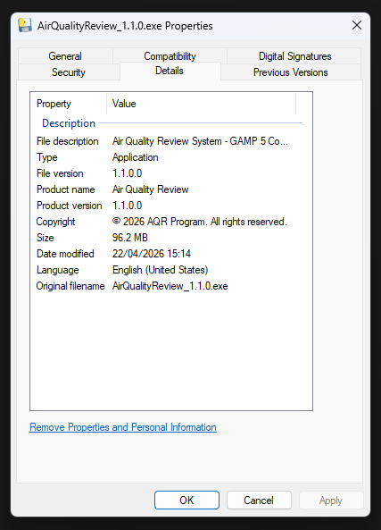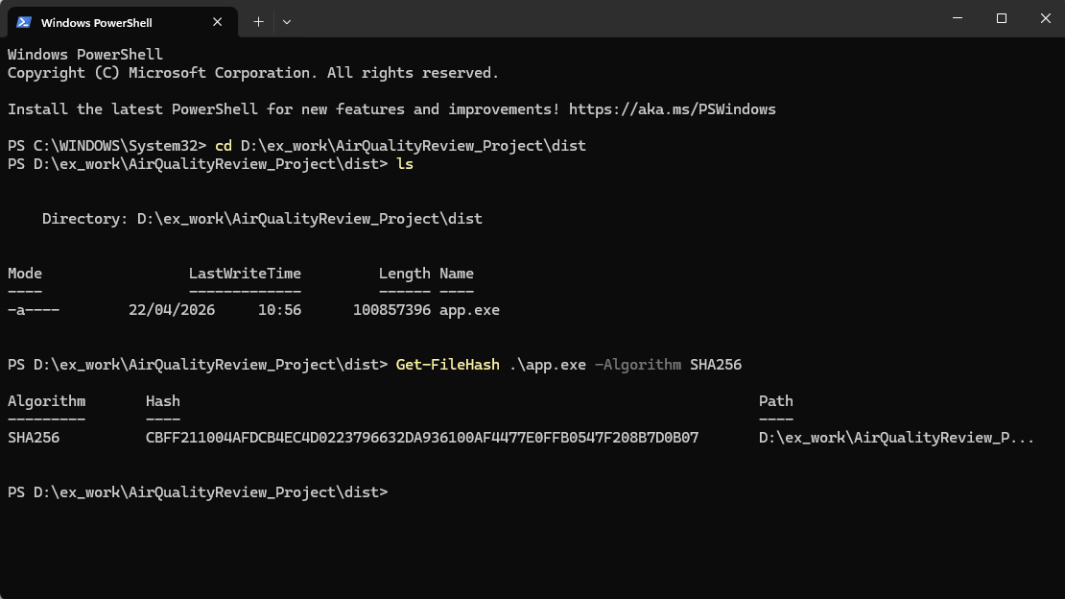

- IQ-TC-02: Directory Structure Verification
Objective:
To verify that the system successfully initializes its required environment by automatically creating mandatory directories and the core integrity log file upon execution.
Procedure:
  - Initial Execution:
- Navigate to the application root directory (e.g., C:\AQR_System\).
- Double-click AirQualityReview.exe to launch the application for the first time.
- Wait for the Graphical User Interface (GUI) to appear or for the process to initialize, then close the application.
  - Visual Inspection:
- Using Windows File Explorer, inspect the contents of the application root directory.
- Verify the presence of the newly created folders: ./reports and ./logs.
  - File Verification:
- Enter the ./logs folder.
- Verify the presence of the audit_trail.log file.
Acceptance Criteria:
  - The ./reports folder is automatically generated and present in the root directory.
  - The ./logs folder is automatically generated and present in the root directory.
  - The audit_trail.log file is successfully initialized and located within the ./logs directory.
Results: Complied with the acceptance criteria
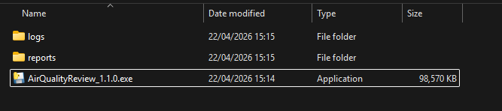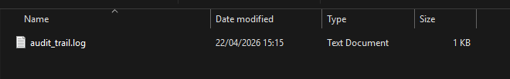

- IQ-TC-04: Automated Folder Initialization (Ref: CS 2.0)
Objective:
To verify the system's ability to self-heal and re-initialize its required operating environment by automatically re-creating critical folders if they are accidentally deleted or missing.
Procedure:
  - Environment Preparation:
- Navigate to the application root directory (e.g., C:\AQR_System\).
- Ensure the application (AirQualityReview.exe) is currently closed.
  - Simulation of Missing Components:
- Select the ./logs folder and delete it.
- Select the ./reports folder and delete it.
- Confirm that both folders are no longer present in the root directory.
  - System Re-initialization:
- Double-click AirQualityReview.exe to launch the application.
- Observe the application startup process to ensure no "File Not Found" or "Access Denied" errors occur during initialization.
  - Verification of Self-Healing:
- Switch back to Windows File Explorer and inspect the root directory.
- Verify that the ./logs and ./reports folders have been automatically re-created by the system.
Acceptance Criteria:
  - The application launches successfully without displaying any system errors or fatal exceptions.
  - The system must automatically re-create the missing ./logs and ./reports folders with correct directory permissions.
Results: Complied with the acceptance criteria
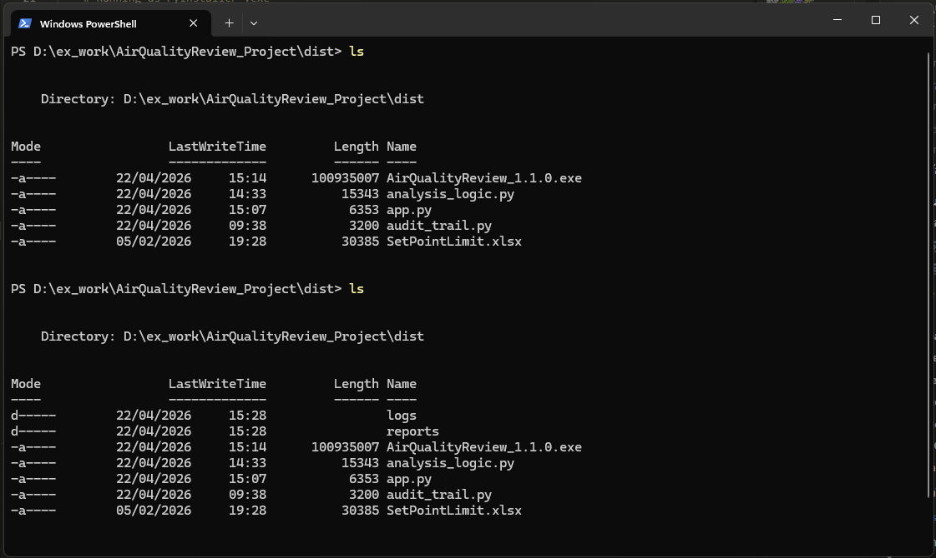

- IQ-TC-06: Standalone Isolation Verification
Objective:
To prove that the application is fully standalone and capable of executing all core functions without external network dependencies or a pre-installed Python runtime environment.
Procedure:
  - Network Isolation:
- Disable all network interfaces on the workstation (e.g., Turn off Wi-Fi, unplug Ethernet, or disable the Network Interface Card (NIC) via Control Panel).
- Confirm that the system has no internet or local network access.
  - Environment Verification (No Python):
- Press Windows + R, type cmd, and press Enter.
- In the Command Prompt, type python --version and press Enter.
- Verify that the system returns an error or a message indicating that 'python' is not recognized as an internal or external command.
  - Application Execution:
- Navigate to the application directory and double-click AirQualityReview.exe.
- Observe the startup process for any external dependency errors.
  - Interface Accessibility:
- Open a web browser (e.g., Microsoft Edge or Chrome).
- Enter the address http://127.0.0.1:5000 in the address bar.
- Verify that the Air Quality Review System dashboard is displayed correctly.
Acceptance Criteria:
  - The application launches successfully in a completely offline environment.
  - The User Interface (UI) dashboard is accessible and fully functional via the local host port.
Results:
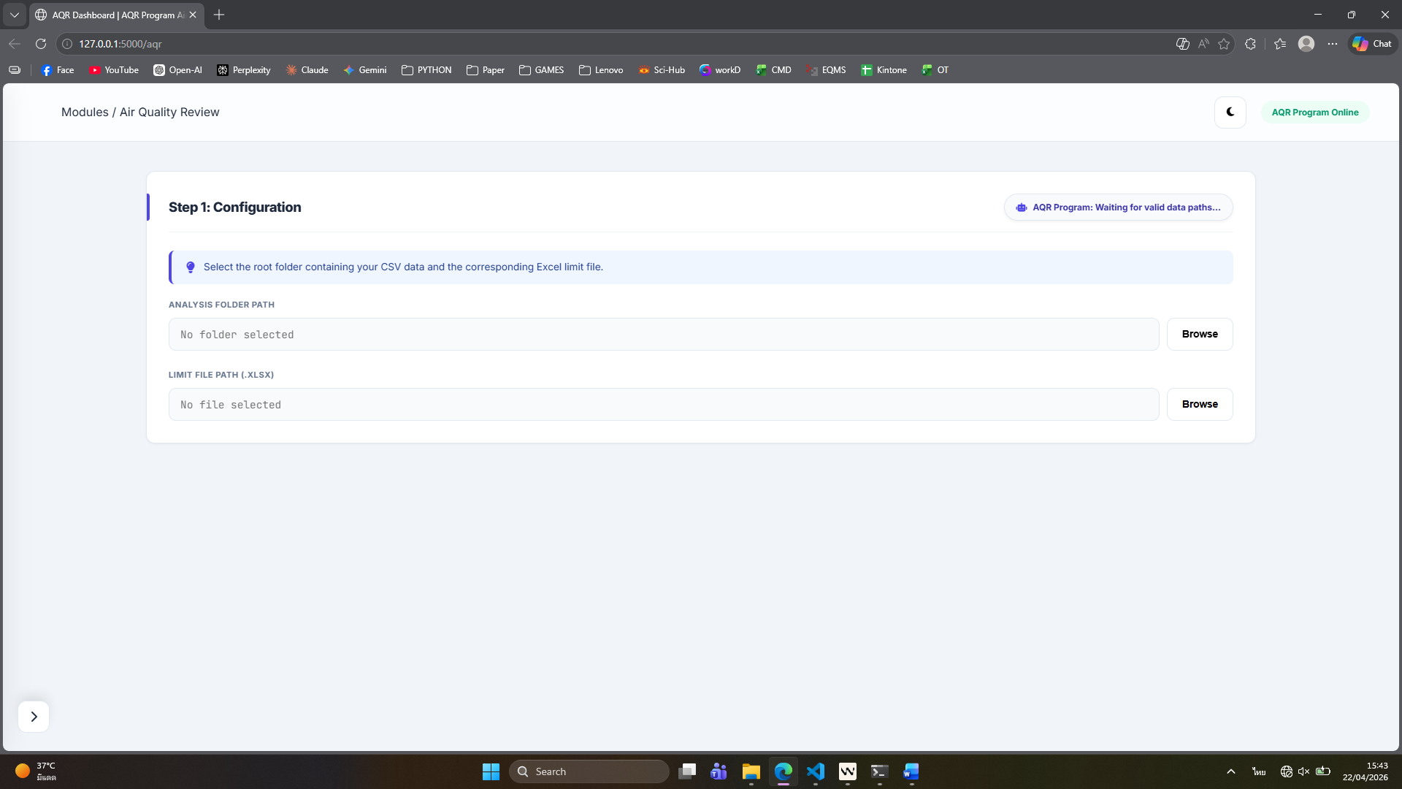

- IQ-TC-07: Pre-Flight Integrity Check Failure (Negative Test)
Objective:
To verify that the system has a robust self-protection mechanism that prevents execution if the Audit Trail has been tampered with or modified by unauthorized means, ensuring compliance with 21 CFR Part 11.
Procedure:
  - Preparation:
- Navigate to the ./logs directory.
- Right-click the audit_trail.log file and select 'Open with Notepad'.
  - Simulation of Unauthorized Modification (Data Tampering):
- Identify a single character or a hash string within the log entry.
- Manually edit or delete characters (e.g., reducing the file content length or changing a specific hex character).
- Save the changes and close the Notepad.
  - System Execution Attempt:
- Return to the application root directory and double-click AirQualityReview.exe.
- Observe the system's response and any error messages displayed on the screen.
  - Verification of System Halt:
- Confirm that the main application Graphical User Interface (GUI) does not open.
- Verify the exact wording of the error message displayed.
Acceptance Criteria:
  - The application must refuse to start and immediately halt all processing.
  - The system must display a fatal error message: "FATAL ERROR 004: Audit Trail Integrity Check Failed".
  - The error details must explicitly mention the security violation or tampered entry.
Results: When edit the audit_trail.log file (Length from 303 to 222) causing SHA256 of audit_trail.log file changed. The AirQualityReview.exe have not been opened and displayed “FATAL ERROR 004: Audit Trail Integrity Check Failed Details: Tampered entry at line 1: Integrity check failed. System execution halted due to security violation.”
